Vanadinite | Pb₅(VO₄)₃X  [X = Cl, F,or OH]
Specimen from Mibladen, Morocco  University of Cincinnati Mineral Collection | Specimen from Puzzler Mine, Yuma AZ  (Click images to enlarge)
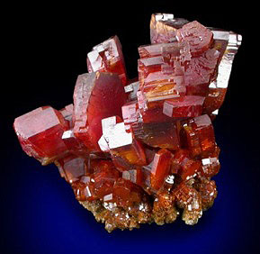 | 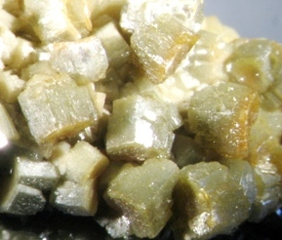
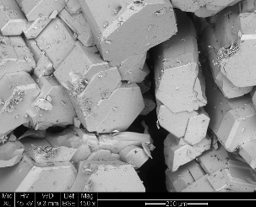 | 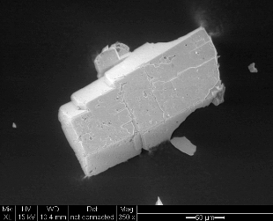
Scanning Electron Microscope image (FEI XL 30 ESEM) | Scanning Electron Microscope image (FEI XL 30 ESEM)

Crystal System | Specific  gravity | Hardness | Color
Tetragonal | 6.94 | 3½ - 4 | Brown, brownish yellow, brown, red, yellow,
Composition | Formula weight = 1416.27 g/mole
Pb | 73.15 % | PbO | 78.8 %
O | 13.56
V | 10.79 | V₂O₅ | 19.26
Cl | 2.50 | Cl | 2.5
Web resources: | http://webmineral.com |  | http://www.mindat.org/

Name is an allusion to its composition

Vanadinite in water distribution systems

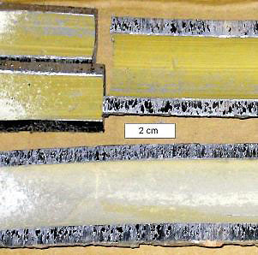 | 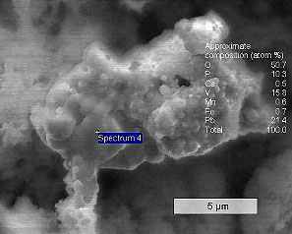
Lead service branch, utility 20. Chloramine disinfection, phosphate corrosion control. | Scanning Electron Microscope image, utility 01 (Hitachi
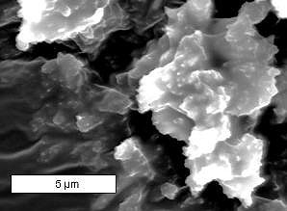
Scanning Electron Microscope image, utility 20 (Hitachi | Scanning Electron Microscope image, utility 20 (FEI XL 30 ESEM)

