Pyromorphite | Pb₅(PO₄)₃X  [X = Cl, F,or OH]
Specimen from Yangshuo, Guangxi, China  University of Cincinnati Mineral Collection |  | Specimen from unknown locality  University of Cincinnati Mineral Collection  (Click images to enlarge)
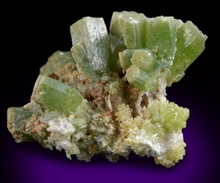 | 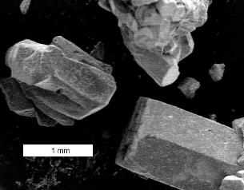
Reflected light photomicrograph | Scanning Electron Microscope image (FEI XL 30 ESEM)

Crystal System | Specific  gravity | Hardness | Color
Hexagonal | 6.85 | 3½ - 4 | Green, yellow, brown, grayish white
Composition | Formula weight = 1356.37 g/mole
Pb | 76.38 % | PbO | 82.2 %
O | 14.15
P | 6.85 | P₂O₅ | 15.7
Cl | 2.61 | Cl | 2.6
Web resources: | http://webmineral.com |  | http://www.mindat.org/

From Greek for fire + form, in allusion to the apparent crystalline form it assume on cooling from fusion

Pyromorphite in water distribution systems

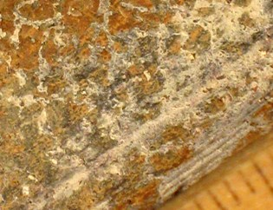 | 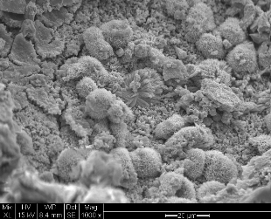
Lead service branch, utility 01. Chloramine disinfection, phosphate corrosion control. | Scanning Electron Microscope image, utility 01 (FEI XL 30 ESEM)
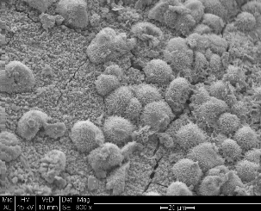 | 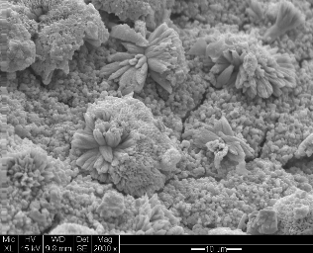
Scanning Electron Microscope image, utility 01 (FEI XL 30 ESEM) | Scanning Electron Microscope image, utility 01 (FEI XL 30 ESEM)

