Leadhillite | Pb₄(SO₄)(CO₃)₂(OH)₂
Specimen from Granby MO | University of Cincinnati Mineral Collection  (Click images to enlarge)
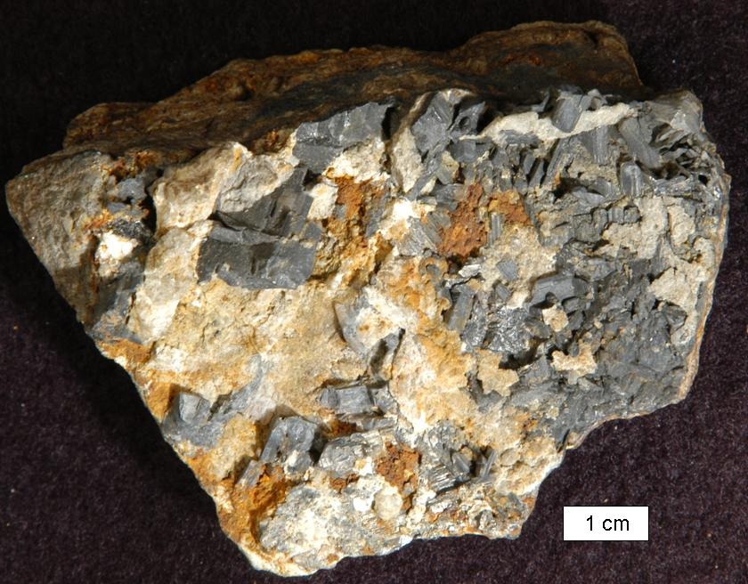 | y
 | Transmitted light photomicrograph (Keyence VHX 600E)
 | Scanning Electron Microscope image (Hitachi )

Crystal System | Specific gravity |  | Hardness | Color
Monoclinic | 6.4 |  | 2½ | Colorless, gray, yellow, white
Composition | Formula weight = 1078.90 g/mole
Pb | 76.82 % | PbO | 82.75 %
C | 2.23 | CO₂ | 8.16
O | 17.80 | H₂O | 1.67
S | 2.97 | SO₃ | 7.42
Web resources: | http://webmineral.com |  |  | http://www.mindat.org/

From the type locality, leadhill in Lanarkshire, Scotland

Leadhillite in water distribution systems

Utility
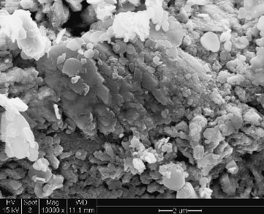
Scanning Electron Microscope image (FEI XL 30 ESEM) | Scanning Electron Microscope image (FEI XL 30 ESEM)

